TNE20003 – Internet and Cybersecurity for Engineering Applications

Portfolio Task – Lab 6 Pass Task

Aims:
- To observe and investigate the functionality of DNS and HTTP applications along with the protocols used at the transport layer. Also to look at email traffic.

Preparation:
- View “”DNS & HTTP”
- & “Transport Layer Services”

Due Date:
- Your Task will be assessed via an online quiz. You must score the required minimum to pass the test. You will be allowed a number of attempts to pass the test at the grade level you attempt. You are encouraged to complete the test at the end of the lab but if you do not, you must complete it before your next lab class.

Load your network from lab 5 and amend the names of the devices as shown in figure 1. If you didn’t save the PT file then you will have build it again as per the requirements in lab 5.
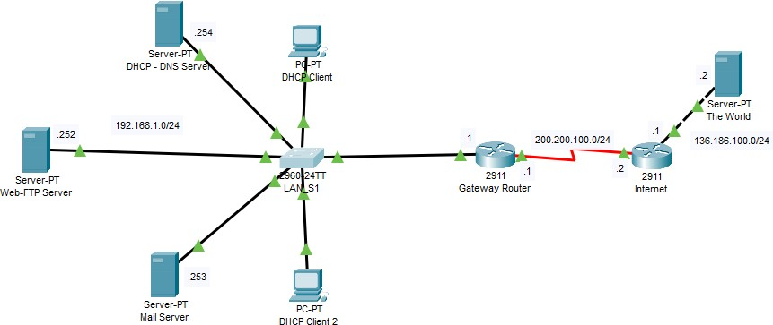

Task 2.
Figure 1

  - Go to the Web server and activate the webpage service.

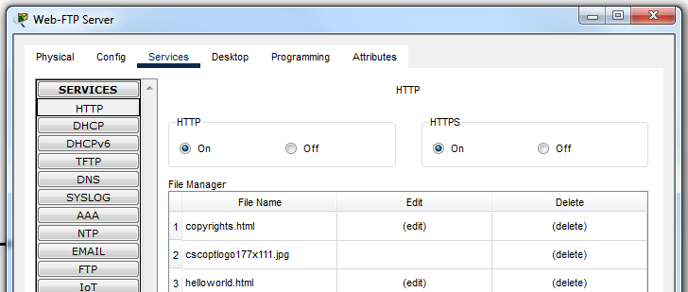
  - Go to the “Services” tab and click on “HTTP”. Then make sure that the service is on as in the pic below. Note that there are already html pages ready to be loaded when someone makes a connection.

TNE20003 – Internet and Cybersecurity
for Engineering Applications
Page 2

    - Go to the DHCP – DNS server.

    - Configure the DNS service. Under the “Services” tab choose “DNS” and turn it on.
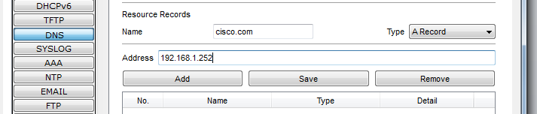
    - Next we are going to add a record for resolving “cisco.com” to the actual IP address of the web server which is 192.168.1.252. Under the heading “Resource Records” add cisco.com in the name field and the “Type field” should be “A Record”. See pic below.

Now click add.

    - Now put in an alias entry in case some users type in www.cisco.com. This time it’s a cname record. Again see pic below.
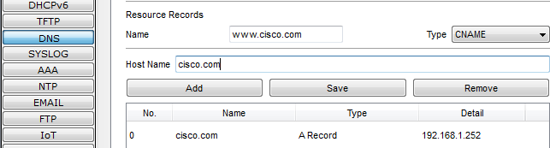

Click add.

    - Test to see if it works. Go to a client and launch a web browser from the Desktop applications. In the URL field type in “cisco.com”. What happens?
I see the cisco packet tracer web Brower.

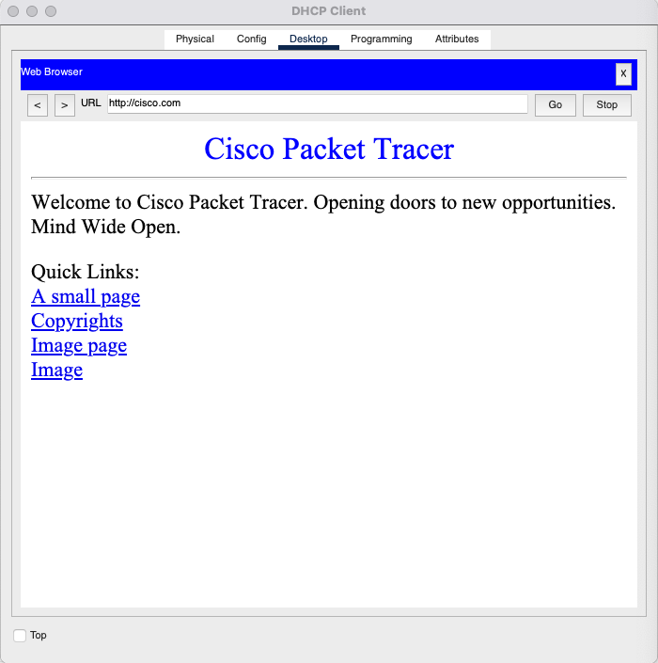

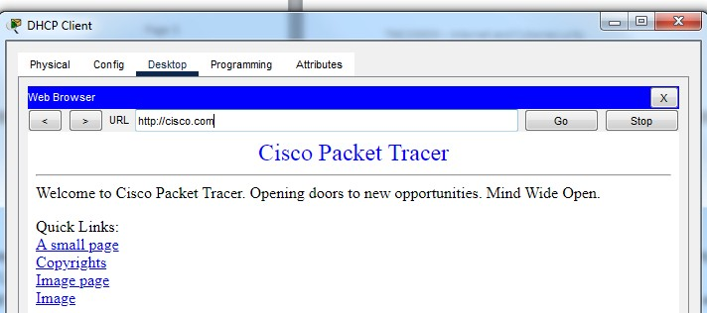

    - Now repeat the above events with the simulation tool on. Under the filter list turn on the protocols shown in pic below
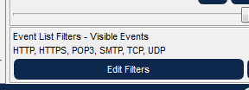
    - When you type “cisco.com” in the URL field you should get the following output in the simulation.
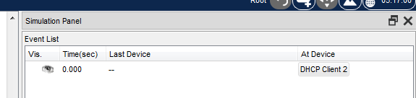
    - Click on the DHCP Client 2 packet and look at the Outbound PDU. What transport layer protocol is being used? What is the destination port? Is this

The outbound shown that the layer 7 transport protocol used is UDP and the destination port is 53.

    - Click the fast forward button below and look at each packet until a time of 0.008

    - At the time of 0.008 look at the packet, in particular look at the “Outbound PDU details” and scroll to the bottom. Now you should know what is going on. If not seek help!
    - Fast forward until you get to a time of 0.015. Look at this packet and find the destination port number. Do you recognize this number??? What does it represent?? What transport layer protocol is being used?
The destination port is 80 which represent HTTP traffic and transport layer protocol is TCP.
    - Fast forward until you get to a time of 0.022. Now go back to the client. What do you see?
The time stopped at 0.019 and it remain the same on the client webpage.
    - Now in the URL field mistype your request such as Cosco.com. Repeat the simulation process and report what happens?The DNS server return an unresolved to the client 2 because the domain name is incorrect.
    - The simulation stops at time of 0.006. If you can’t figure out what happened, go back to the client. What do you see?? Unresolved host address.

Task 4. Set up the mail server and investigate its operation
- Go to the Mail server

  - Under the “Services” tab choose “Email” and ensure both the SMPT and POP3 services are ON. See pic below.
  - Next we are going to give it a domain name and set up some client accounts. See the picture below for details. Remember to click “Set” to create the domain name. Set up 2 users. The first is Dragan with password Fire and the second is Danerys and password Queen

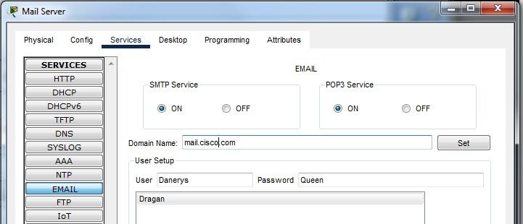

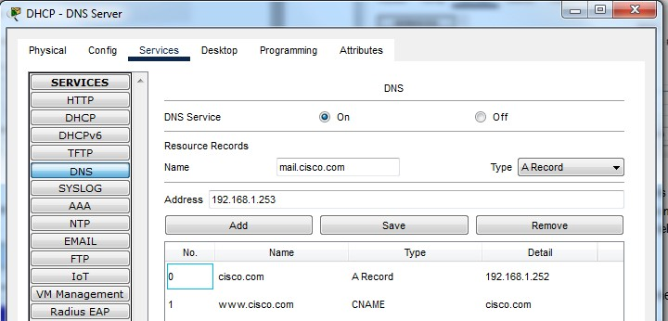
  - Note our system will not know the IP address of this server if we just use the domain name. So, go into the DNS server and resolve the name to an IP address. Click on the DNS server and fill in the details as in the picture below and then click add.
  - Let’s test to see if it worked. Go to a DHCP client and click on the “Email” app under Desktop and fill in the details as in the picture below. Then click save.

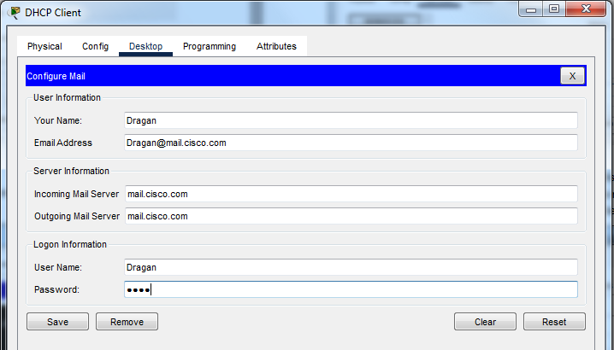
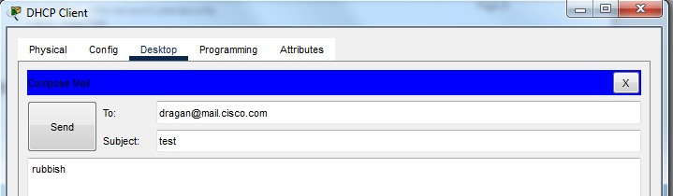
  - Now let’s compose and email to ourselves. See picture below for sample composition.
  - Press send and observe the information provided at the bottom. This clearly shows the resolution of the name to an IP address and then a successful transmission.

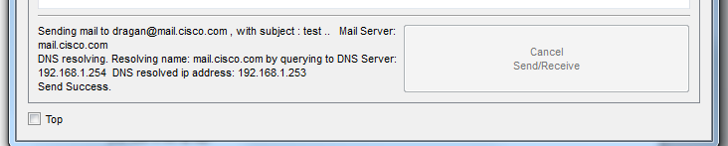

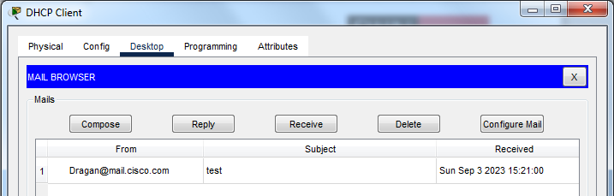
  - Last part is to press “Receive” on the mail browser and the email should pop up as shown in the picture below.

- If you want to see detailed packet information repeat 1 again in the simulation mode and press the fast forward button and observe the packet contents.